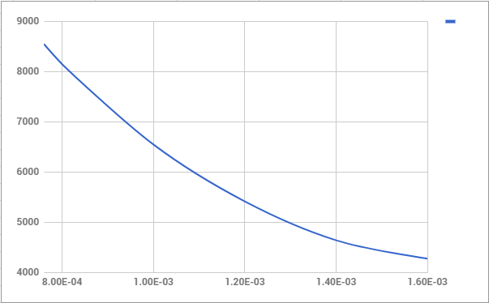

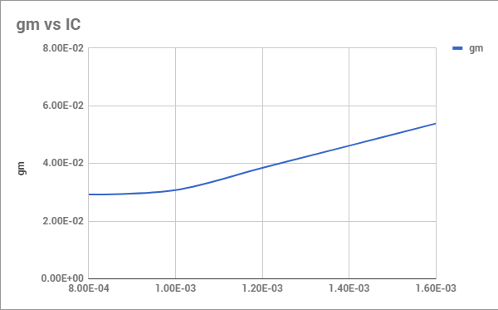

3) first pole at 4.6 Hz

4) Rin = 30 Ohms

Io = .734 mA, Vo = 86.2 mV

Rout = 86.2 mV / .734 mA = 117.4 Ohms

5) Common Emitter Distortion Analysis with Vpp = 10 mV, 15 mV, 20 mV, and 26 mV

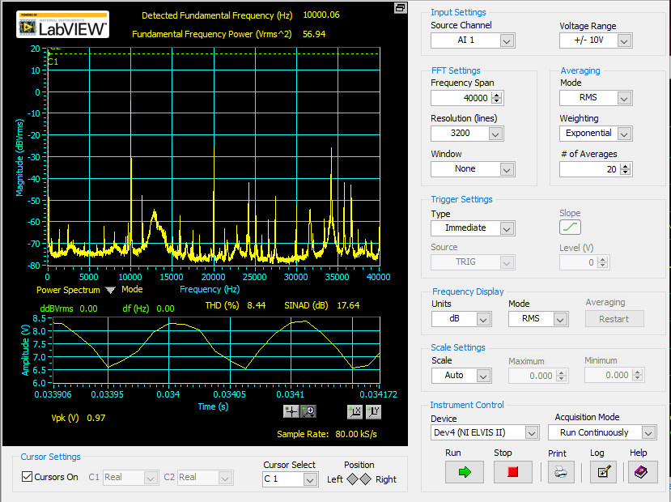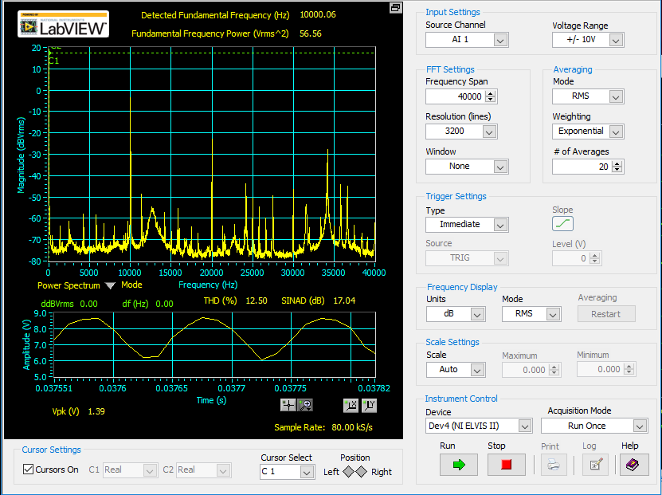

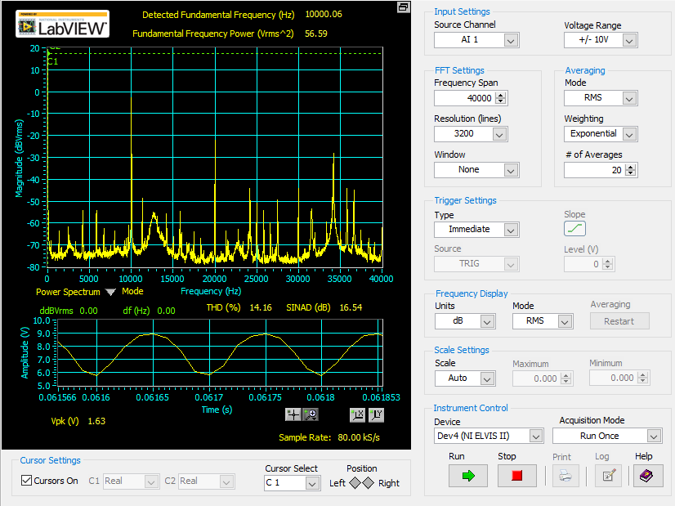

As Vpp increases, Vo begins to clip at the bottom. 